City Tour + Middle of the World (half-day): includes guide and professional driver (shared - Thursdays and Sundays only)
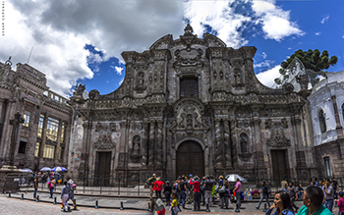 | 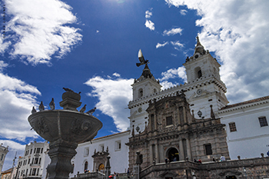 |  | 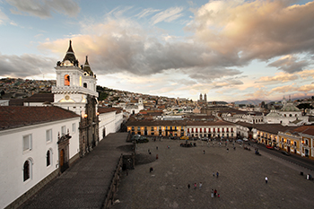
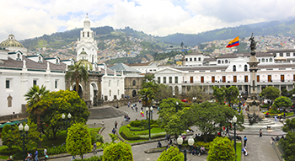 |  | 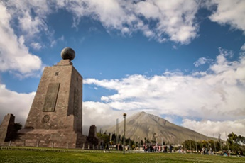
This half-day, shared tour features some of the most iconic sites in Quito’s Historic Center perfectly combined with a visit to the Middle of the World.
The ornate San Francisco Church and Convent, marking the arrival of the first Catholic order in Quito, is considered “America’s Escorial”, built on top of a centuries-old pre-Incan. The church, which features a majestic choral area and a gorgeous crown-like dome, also features the “Winged Virgin” above the main altar. It is a perfect example of Renaissance, Mudéjar, and Baroque Quiteño styles. The interior courtyards and convent are a perfect complement to the visit. This site serves as the inspiration for the Legend of Cantuña, which tells the story of a cunning indigenous worker that managed to deceive the Devil. The imposing facade of the church and convent is as impressive as its grandiose steps, which land upon San Francisco Plaza, where we enjoy a light snack at the Tianguez (restaurant) while learning about this place –one of the most iconic urban settings in the country’s capital. The plaza occupies the same space where once there stood an indigenous marketplace.
La Compañía Church is considered the crown jewel of Quito’s Historic Center and one of the most important examples of baroque architecture in the world. This masterpiece is the product of a European vision realized through the in situ work of creative and talented artisans in the artistic tradition of the Quiteño School.
Independence Square (also known as the Plaza Grande) is at once, a hub for city planning and development and a nexus for Ecuadorian society, given that the Presidential Palace (Carondelet), the Archbishop's Palace, the Cathedral of Quito, and the city’s Municipal Offices are all located around it. Standing tall at the center of the square is a monument that honors the nation’s colonial independence, constructed out of marble and bronze in 1906.
The tour also includes a visit to Middle of the World City, located just 8.3 mi (about 13.5 km) north of Quito at a latitude of 0°0’0. This site honors the French Geodesic Mission, which, near the end of the 18th century, precisely determined the location of the equinoctial line. The mission’s measurements became the basis for the metric system as we know it today. The tour includes a visit to the Middle of the World Monument, which focuses on the history of the Middle of the World City and the scientific experiments performed there. Also, the monument features artifacts from various indigenous peoples.
Recommendations
• Dress in layers and bring a sweater or jacket.
• Wear comfortable walking shoes.
• Bring a hat, sunglasses, and sun protection (SPF 40+).
• Depending on the weather, bring a raincoat or umbrella.
Notes
• The tour is offered on Thursdays and Sundays and lasts approximately 5 hours.
• Church visits do not take place on Sunday mornings.
• We visit various religious buildings, and guests are encouraged to dress accordingly, in other words, that they wear pants or a long skirt.
Included: Shared guide and professional driver, plus all entrance fees.
Not included: Tips, drinks, meals, personal expenses.

